**Week-2**

**Mockito exercises**

**Exercise 1: Mocking and Stubbing**

**Scenario: You need to test a service that depends on an external API. Use Mockito to mock the external API and stub its methods.**

**Pom.xml:**

<dependency>

<groupId>org.junit.jupiter</groupId>

<artifactId>junit-jupiter</artifactId>

<version>5.9.1</version>

<scope>test</scope>

</dependency>

<dependency>

<groupId>org.mockito</groupId>

<artifactId>mockito-core</artifactId>

<version>4.8.1</version>

<scope>test</scope>

</dependency>

**ExternalAPI.java:**

package practice;

public interface ExternalApi {

String getData();

}

**MyService.java:**

package practice;

public class MyService {

private ExternalApi api;

public MyService(ExternalApi api) {

this.api = api;

}

public String fetchData() {

return api.getData();

}

}

**MyServiceTest.java**

package practice;

import org.junit.jupiter.api.Test;

import static org.junit.jupiter.api.Assertions.*;

import static org.mockito.Mockito.*;

public class MyServiceTest {

@Test

public void testFetchDataReturnsMockedValue() {

// Create a mock object for the external API

ExternalApi mockApi = *mock*(ExternalApi.class);

// Stub the method to return a predefined value

*when*(mockApi.getData()).thenReturn("Mocked Response");

// Inject mock into the service

MyService service = new MyService(mockApi);

// Call the method and verify result

String result = service.fetchData();

*assertEquals*("Mocked Response", result);

// Optional: show output in console

System.*out*.println("Test passed with result: " + result);

}

}

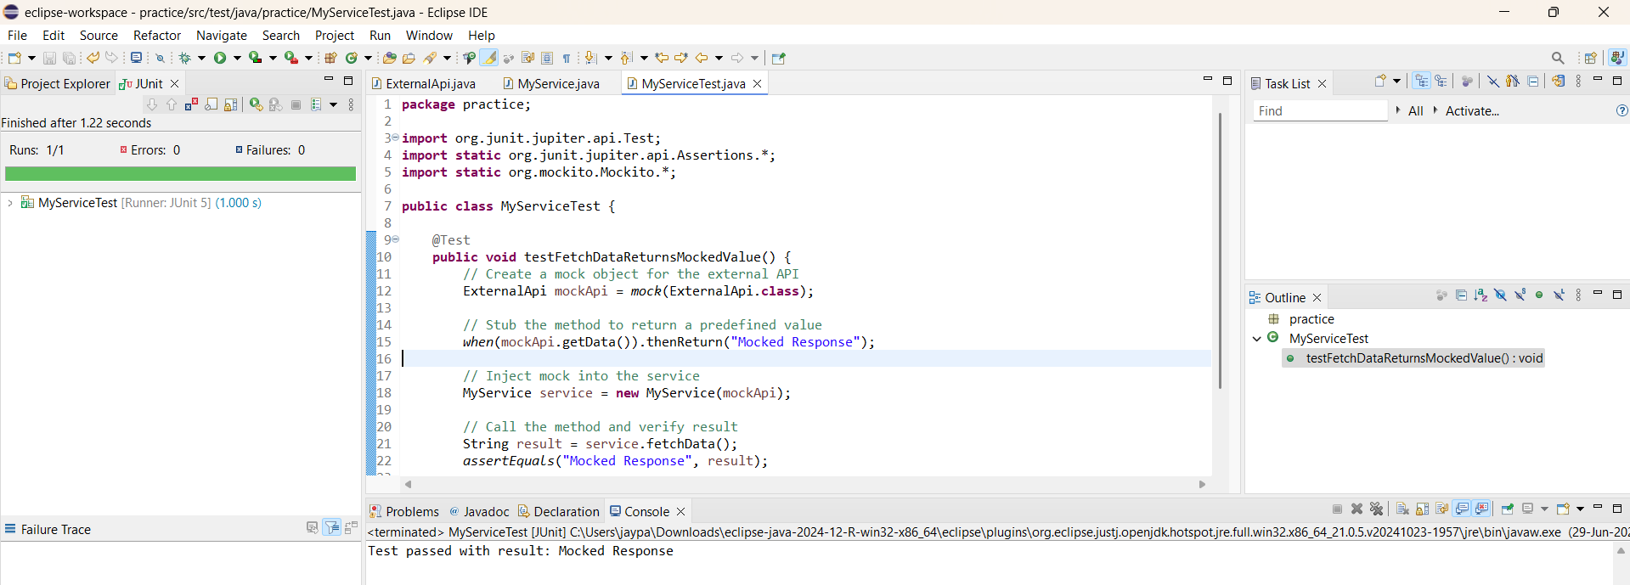

**Exercise 2: Verifying Interactions**

**Scenario: You need to ensure that a method is called with specific arguments.**

**ExternalAPI.java:**

package practice;

public interface ExternalApi {

String getData();

}

**MyService.java:**

package practice;

public class MyService {

private ExternalApi api;

public MyService(ExternalApi api) {

this.api = api;

}

public String fetchData() {

return api.getData();

}

}

**MyServiceTest1.java:**

package practice;

import org.junit.jupiter.api.Test;

import static org.mockito.Mockito.*;

public class MyServiceTest1 {

@Test

public void testVerifyInteraction() {

// Create a mock

ExternalApi mockApi = *mock*(ExternalApi.class);

// Use the mock

MyService service = new MyService(mockApi);

service.fetchData(); // this should call mockApi.getData()

// Verify interaction

*verify*(mockApi).getData();

System.*out*.println("Verified that getData() was called");

}

}

